Teacher: Ms. Beth Christie beth.christie@nbed.nb.ca (506) 575-6020
Physical Geography aims to answer the following questions:
- What is the current state of the planet
- How did it get to be this way?
- What is the long term future of planet Earth and its passengers?
Units of Study: The Nature of Physical Geography
The Earth in Space
Structure of the Earth
Continental Drift and Plate Tectonics
Shaping the Landscape

Mark Breakdown:

Observations and Conversations 10% Projects 25% Quizzes and Unit Tests 30%
Activities/Classwork (daily work, assignments, participation etc.) 15% Final Exam 20%

The following are compulsory assessments for the course:
- Term Project
- Exam

This means that, regardless of the student’s mark, no mark will be granted in the course if these assessments are not completed satisfactorily and passed in.

- Other, non-compulsory assessments will lose 10% of the value of the assignment for each day that it is late up to 40%.

- Test review packages are expected to be completed as “the ticket” to write the test and time will be given in class to complete these packages. If the review is not completed, students will be finishing the package during that test period. They will then need to write the test outside of class time.

Course Expectations:

- Students will keep folders with class notes and activities. Each folder will be submitted at the test. The folder must be complete. Students will receive a grade on their folder which counts towards the observations and conversations.
- Students will work, when class time is given to complete work.
- Students will be respectful of all others in the classroom.
- If a test or other assessment is missed, it is the student’s responsibility to approach the teacher about making up the assessment. This will be done on the student’s own time (at lunch or afterschool) and not during class time.

Textbook: PLANET EARTH: A PHYSICAL GEOGRAPHY

Students are assigned a textbook, for which they are responsible for the entire term. Loss or failure to return the textbook will require the student to pay its replacement cost.

Behavioural Expectations

As a student once summarized it to me, it comes down to this:
- Try your best
- Come to school everyday
- Do good/Be kind
School policies are available electronically or in hard copy from the office by request.
A bottle of water is allowed in class. Other food and drinks are to be consumed at break/noon.

Extra Help

My supervision schedule changes every month, so I post my noon hour availability on the whiteboard outside my room each month. I am also available for extra help as of 8 am every morning and after school until 3:55 pm by appointment.
Movies:

As part of the study of volcanoes, we will be watching the film “Dante’s Peak” (1997) in order to look for scientific inaccuracies.

Parent Sign-Off – please return the portion below signed by the parent or guardian.

I have read and understand the course requirements, the policy on compulsory assignments and am aware the class will be using the movie Dante’s Peak to reinforce their knowledge of volcanoes. We will also be watching network produced documentaries.

____________________________ ______________________ __________________________
Student Name Parent/Guardian Signature Date

Parent E-mail: _____________________________
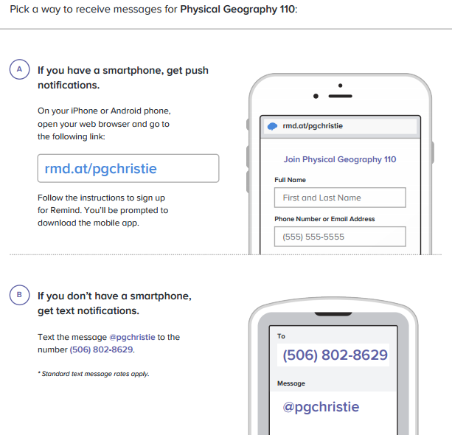
Parent Phone: _____________________________

